- Primary Information
Sample ID | R/2024050001 A
Date Received | 30 Mei 2024
Quotation ID | Q-2405-099
Turn Around Time | 10 Juni 2024

- Customer Information
Customer Name: | PT. Contoh Pelanggan Sejahtera
Contact Person: | Bpk. Budi
Mobile: | 0812345665
Email: | example@example.com
Address: | Jl Merdeka 19, Jakarta, Indonesia

- Sample Details
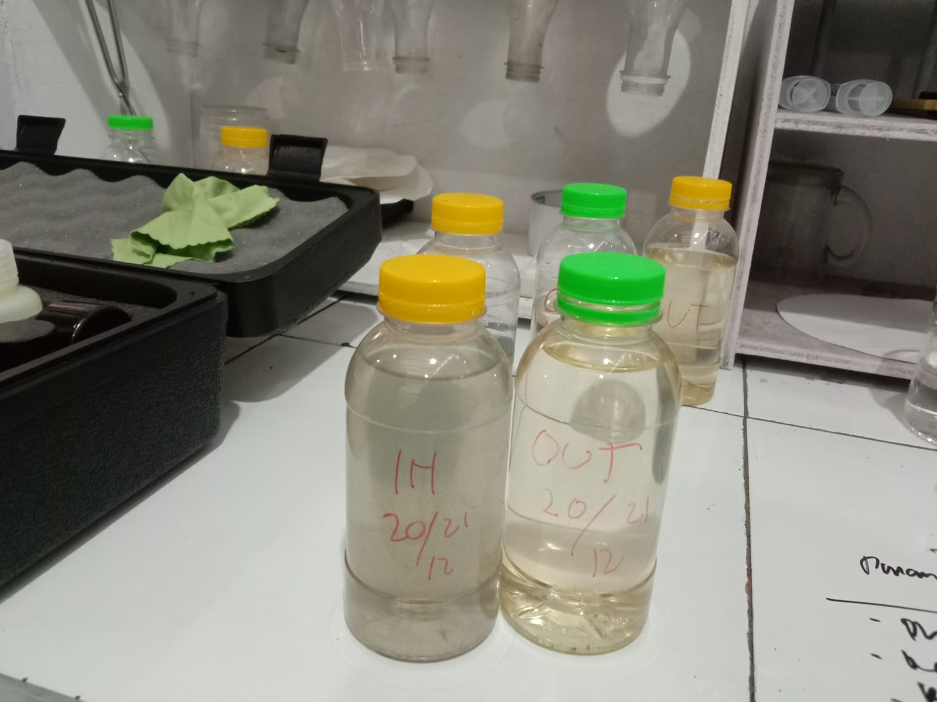
Sample Photo
Matrix / Sample Type: | Air Limbah Domestik (Domestic Wastewater)
Quantity & Unit: | 2 x 1 Liter Botol Kaca
Storage Location: | Kulkas 1 - Rak B (Chiller 4°C)
Condition Upon Receipt: | Lainnya: Suhu saat diterima 6°C. Segel sedikit terbuka.

- Sampling
- Sampling Data
Sampling Date & Time: | 29 Mei 2024, 09:30 WIB
Sampling Location: | Outlet IPAL - Titik Koordinat: -6.2000, 106.8166
Sampler Name: | Ahmad Junaedi (Petugas Lab) / Customer
Sampling Method: | ☑ Grab (Sesaat) ☐ Composite (Gabungan)
Weather Condition: | Cerah / Berawan / Hujan

- Field Measurements
Parameter | Result | Unit | Method/Alat
Temperature (Suhu) | 28.5 | °C | Thermometer
pH (Lapangan) | 7.2 | - | pH Meter Portable
DO (Dissolved Oxygen) | 5.4 | mg/L | DO Meter
Debit (Flow) | 1.5 | m³/s | Flowmeter

- Requested Test
No | Parameter Uji | Sub-Parameter | Metode | Alat / Instrumen | Due Date
1 | Logam Berat | Arsen (As) | SNI 6989.82:2018 | ICP-OES | 02/06/2024
2 | Logam Berat | Kadmium (Cd) | SNI 6989.82:2018 | ICP-OES | 02/06/2024
3 | Logam Berat | Kromium (Cr-VI) | SNI 6989.82:2018 | ICP-OES | 02/06/2024
4 | Logam Berat | Tembaga (Cu) | SNI 6989.82:2018 | ICP-OES | 02/06/2024
5 | Logam Berat | Besi (Fe) | SNI 6989.82:2018 | ICP-OES | 02/06/2024
6 | Logam Berat | Timbal (Pb) | SNI 6989.82:2018 | ICP-OES | 02/06/2024
7 | Logam Berat | Mangan (Mn) | SNI 6989.82:2018 | ICP-OES | 02/06/2024
8 | Logam Berat | Merkuri (Hg) | SNI 6989.82:2018 | ICP-OES | 02/06/2024
9 | Logam Berat | Seng (Zn) | SNI 6989.82:2018 | ICP-OES | 02/06/2024
10 | Logam Berat | Nikel (Ni) | SNI 6989.82:2018 | ICP-OES | 02/06/2024
11 | Logam Berat | Selenium (Se) | SNI 6989.82:2018 | ICP-OES | 02/06/2024
12 | Logam Berat | Kobalt (Co) | SNI 6989.82:2018 | ICP-OES | 02/06/2024
13 | pH | - | SNI 06-6989.11-2004 | pH Meter Mettler | 31/05/2024
14 | COD | - | SNI 6989.2:2019 | UV-Vis Spectro | 02/06/2024
15 | TSS | - | APHA 2540 D | Analytical Balance | 02/06/2024

Assigned By:
Supervisor,
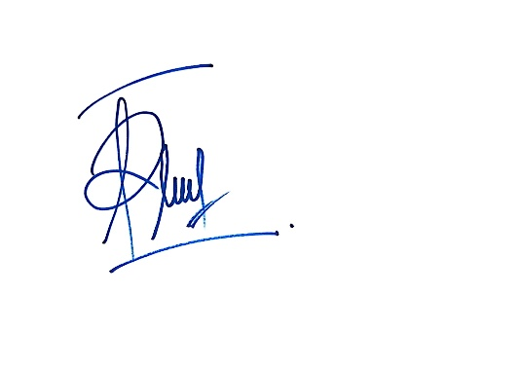
Farrel Arya Andhika

